Part 1
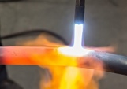

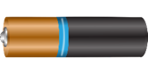
- What sort of energy store do the following examples have?
a. b. c.

- Name and describe the four force pathways.

- Write down the correct answer to complete the statement.
Energy can not…
… be transferred from one source to another.
…be created or destroyed.
…travel along a pathway to another store.
- A pole vaulter just clears the bar which is 5.1 m high. His mass is 62 kg.
(g = 10N/kg)
  - What type of stored energy does he have as he clears the bar?

  - Work out how much stored energy the pole vaulter has due to his position above the ground.

  - As he falls back to the ground, this energy store will be transferred into a new energy store. Name this new energy store.

- When a football is kicked it gains kinetic energy.
  - What is the formula used to calculate kinetic energy?

  - The football has a mass of 0.4 kg and when kicked has a velocity of 15 m/s. Work out the kinetic energy of the moving ball?

- Copy and Complete the energy store and pathway diagrams for the objects described.

  - A moving car braking to a stop.

  - Bringing water to the boil on a gas hob.
7. Describes the main change in energy stores for:
a. A bowling ball hitting a pin

8. Describes the main change in energy stores for:
b. Boiling water in an electric kettle
Part 2
- In a “closed” system …..........
  - energy can be transferred but there is no net energy loss.
  - energy and mass are transferred in and out of the system.
  - energy cannot be transferred between different energy stores.
- The energy transfer diagram for a mobile phone shows that 100 J of electrical energy produces 45 J of light energy and 36 J of sound energy. How much thermal energy will be dissipated by the phone?
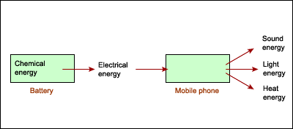

- Describe how the thermal energy produced by a bus driving along a road is dissipated.

4. a. The diagram shows the main energy transfers for an electric fan. Complete boxes A to D
showing the energy stores involved. Use the size of the arrows to help you.
b. State why the total energy supplied to an electric fan must always equal the total energy
transferred by the electric fan.

5. a. The diagrams show two different types of loft insulation.
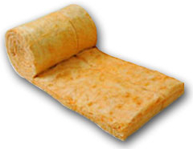
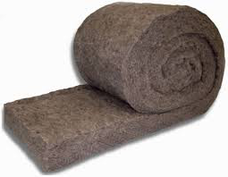
Fiberglass insulation Wool insulation

The wool needs to be thicker to have the same insulating properties. Explain which material has the highest thermal conductivity?
b. Explain how trapped air reduces the rate of heat loss, in terms of thermal conductivity.
Part 3
- What is a fossil fuel?
- Copy and complete the table below by ticking the correct box for each energy source.
Energy source | Renewable | Non-renewable
Bio-fuels
Oil
Nuclear
Hydro-electricity
Wind turbines
Coal
Solar power
Natural gas

- What is a renewable energy source?

- Why are fossil fuels considered to be a more reliable energy resource than renewable energy resources?

- Despite a large investment by the UK government in wind power, the amount of fossil fuel used has not seen a decline. Give a possible explanation for this.

- The UK government is committed to investing in a "blend" of energy supply types to provide the UK’s energy needs for the next 100 years. Give an advantage of this rather than using just coal.
- The graph shows the world use of renewable energies over the past sixty years.
  - Why has the use of wood increased very little over this time?
  - A lot of money has been invested in wind turbines. Why does this energy source not produce as much as any other renewable resource?
- Copy and complete the table to give energy sources that could be used in each situation.
Energy use | Energy source 1 | Energy source 2
Running a car
Producing electricity
Heating the home
Powering a train

- Describe how human activities have contributed to the greenhouse effect?

- Explain how burning coal in power stations contributes to global warming.

- Describe two problems associated with the storage of waste from nuclear power stations.

- State two reasons why people might object to having a wind farm built close to their homes.

